Spring boot security.

Spring boot provide starter which help to achieve security for to access our resource ie getting web pages or rest api end point with authentication and authorization.

Authentication mainly use to access the any resource like web page or end point with login details like username or emalid and password.

Authorization base upon role we can apply some restriction to access specific resources.

Spring boot provide password encoded and decoded features which storing particular user details in database.

Spring boot even support advanced level authentication as well as authorization using JWT (Json Web Token a) OAuth 1.x and 2.x version.

Spring boot rest api with default security login details.

Web starter -🡪 to create view as Thymeleaf or Rest API

Security starter 🡪 to security features

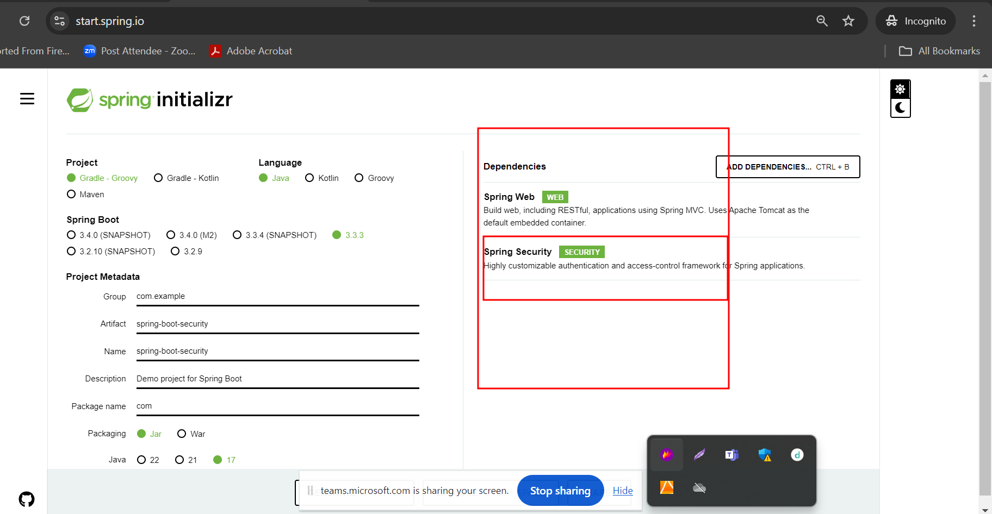

Once you added security starter by default security features applied for you web page. While accessing any end point it will ask use username and password

By default user name is user and password random password generated on console.

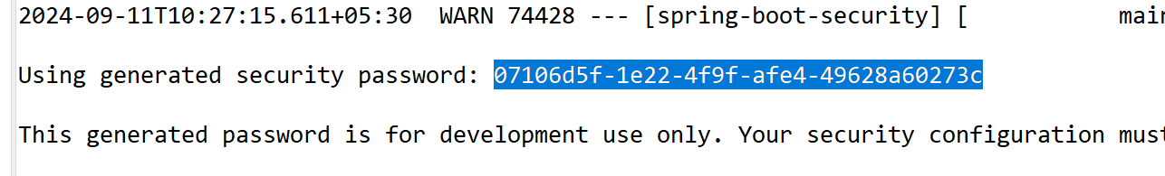

If you want logout the session please hit the URL as

<http://localhost:portnumber/logout>

logout is pre defined end point to logout our session.

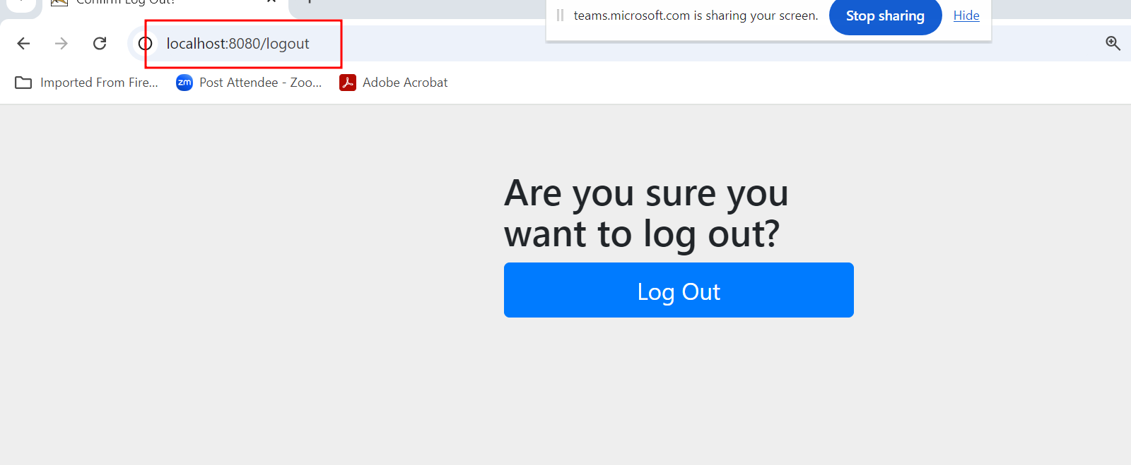

If we want to provide custom user name and password

That we can achieve using two way

1. Using application.prorties files
2. Using java class with @Configuration

Using application.properties file providing user name and password.

If we want to provide the username and password details we need to create user defined class with @Configuration annotation.

We nee use annotation ie @EnableWebsecurity . this annotation help use to enable security features inside configuration class.

Then spring security starter or dependency provided few core api

1. UserDetailsService
2. UserDetails
3. User

Both are interfaces provides by spring security which hold the user information.

Spring 2.x version different API for security

Spring 3.x version different API for security.

Authentication and Authorization to access specific rest api and storing user details memory.

Admin -🡪 can access all end point

User 🡪 it can access specific end point

AddProduct, DeleteProduct,Update and ViewProduct

Add can do all operation on product

User can only view the product it can’t access add, delete and update

